Taxi Riding Data Analysis and Demand Prediction System

Zhenwei He
Department of Computing and Software
McMaster University
Hamilton, Canada
@mcmaster.ca
Wenqi Xu
Department of Computing and Software
McMaster University
Hamilton, Canada
xuw63@mcmaster.ca

Abstract—Riding by taxi is an important way for people to travel in the city. This report analyzes the NYC taxi riding data and presents a prediction model on riding demand. We leverage millions of taxi trip data and apply random forest regression machine learning algorithm on PySpark to make the prediction on taxi demand, average fare and tips. We first process the raw datasets and pick up several features to make preparation for prediction. And then we apply machine learning model and tune parameter to achieve good performance. Finally, we analyze the experiment results.
Keywords— data analysis, taxi data, random forest regression, big data, Spark, MLlib

Introduction
Taxi has always been a significant way to travel in the city. There are over 200 million taxi rides in NYC each year. Data about these taxi rides have been available. How to use these data to make transportation more efficient is a challenge. It would be useful if taxi drivers can know where he can pick up more passengers and get more tip on a specific time. Data about these taxi trips has been available to the public, making it possible for data analytics. We are eager to see a big data solution to this problem.
In our analysis, we attempt to examine and understand the provided features to create a prediction model for this problem. The primary objective of our project was to predict the density of taxi pickups throughout New York City as it changes from day to day and hour to hour. For example, give a specific pick up location, date and time, we would like to predict the number of the pickups in that location to a high accuracy.
Our work can help make traffic more efficient in the flowing ways. For the taxi driver, riding demand prediction can help them make better pick up decisions. Taxi companies can maximize their utilization by diverting the cabs into the locations during specific times; Planners can use the model predictions for traffic management on specific daytime and locations.

Related work
Analysis of taxi riding data is an urban computing problem, which connects sensing technologies, novel visualization methods, advanced data management and analytics models to create solutions that improve the environment (Schneider, 2015 Nov. 17). Todd W. Schneider (Zhang, Cheng & Xiong, 2015 May 15) analyzed New York taxi riding pattern. The result shows some compelling pattern for different Taxi (Yellow taxi, Uber, and Lyft) and for different areas as well as pick up time. Zhang (Zheng et al., 2014) analyze NYC taxi data on the topic of "Understanding Taxi Economics." The question of how the revenue varying over different time and neighborhood is investigated. It is implemented in MapReduce Framework with Hadoop Streaming API and Python. Our project is different from the above in the following aspects: Instead of analyzing taxi riding pattern, we focus on using machine learning models predict taxi riding demand, average fare and tip and so forth, which provide direct economic benefits.

Datasets and data processing

Datasets
The data provides the details of green taxi rides in the New York City from April 2016 to June 2017. This data is provided by the NYC Taxi and Limousine Commission. The data for each month is about 90Mb and consists of roughly over 1 million trips. Each trip records fields: pick-up and drop-off dates/times, pick-up and drop-off neighborhood, trip distances, itemized fares, payment types, and driver-reported passenger counts.

Data processing
We first throw out unnecessary information like drop-off location, time and travel distance. Then for each set of unique feature combination of pickup location, hour, is a business day or not, we calculate the average rides in hour, average trip fare, and tips. Finally, we combine the data of each month and turn it into the correct format to feed into the model for training.
Our goal is to predict three outcome variables that measure the ride demands:
- count: Hourly total number of pickup rides in a neighborhood.
- fare: Average trip fare for each ride.
- tip: Average tip fare for each ride.
We predict three variables above based on two numerical and one categorical feature:
- hour (numerical): Time when the pickup happens, only keeping the hour part.
- business day (numerical): binary variable that denotes whether a day is weekdays or weekends.
- location: (categorical): The neighborhood where pickup location lies within. NYC is divided into 265 neighborhoods in datasets.

Machine Learning algorithm
Because the ride demands prediction is a regression problem with both numerical and categorical features and non-linear relationship between features and predicted variables, we choose the Random Forest regression model to make the predictions.
The Random Forest method includes following advantages:
- It can reduce the ‘Overfit’ phenomenon on training datasets.
- It can rank the importance of features.
- It can handle both categorical & numerical features.
- It can well-handles unbalanced data & non-linear relationship.
- It remains accurate when a lot of data missing.
- It is easy to interpret the result because it is based on decision trees.
The major steps of the random forest algorithm are as follows:
- Assume there are T trees and N input cases in total. Then for each tree, sample n<N cases at random with replacement as the training dataset for this tree.
- Assume there are M input features. For each tree, sample m<M features at random without replacement for each node on the same branch of the tree. Then select the feature (and the threshold of this feature) which can do the best binary split on that node, according to some objective functions such as Gini and Entropy.
- Train each tree to the largest extent or reach the max depth set in advance.
- Use ensemble methods on all the trees to predict new input, such as majority votes for classification, and average for regression.
The original dataset is divided at random into training dataset (80%) and test dataset (20%). We train three different Random Forest models on training dataset to predict Count, Fare, and Tip and use the root-mean-square error to test the performance of models on test dataset.
After the Random Forest models is built, we tune the models by changing the value of key hyperparameters:
- num_trees: the number of decision trees in a Random forest. Usually more trees get better accuracy of predication but more computing time.
- feature_subset_mode: the features in each node to find the best split. Usually this value should get larger while there are the more useless features.
- max_depth: the maximum depth of a decision tree. Usually the larger depth gets better accuracy of prediction but more computing time.
- max_bin: the maximum number of bins in each feature. The bins is to group the value in each feature to improve the computing performance to find the best split.
More details about the Random Forest regression algorithm can be found in Murphy (2012).

Implementing with pysaprk
The Random Forest algorithm is naturally suitable for parallel computing, so we use the Apache PySpark MLlib to implement it with MapReduce method.
The function in PySpark MLlib to train the Random Forest regression model is as Figure 1.
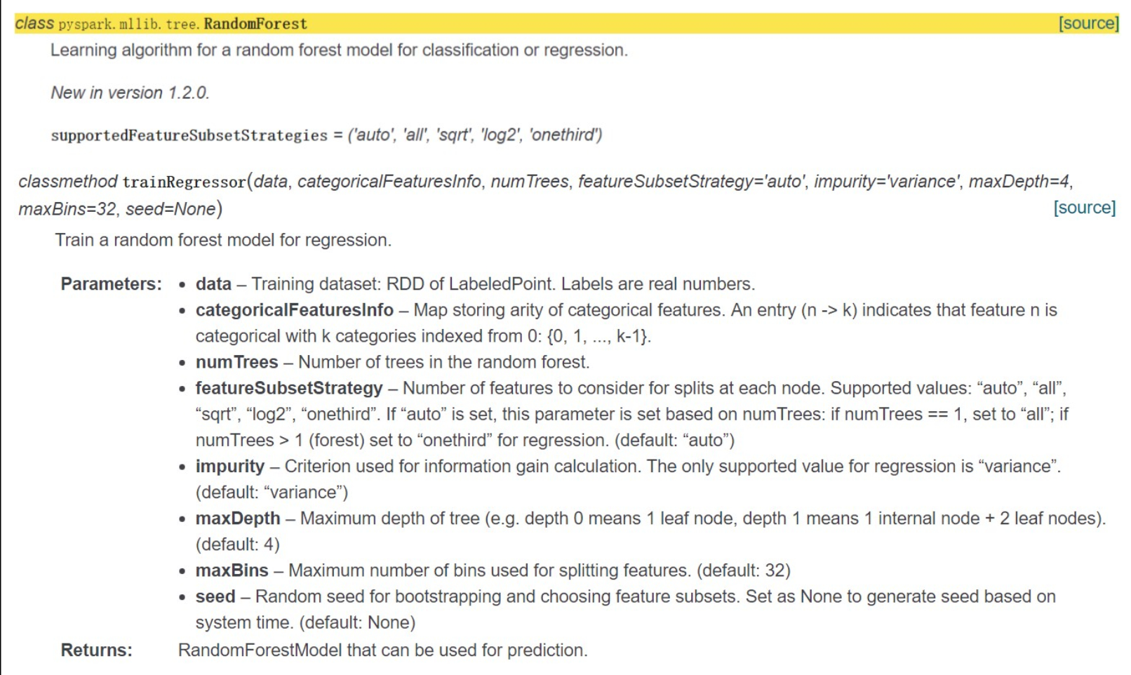
Figure1: Function to train Random forest regression models in PySpark
Major steps to use PySpark to train a Random Forest regression model:
- Create a spark session and a spark sql context;
- Load the original dataset (after pre-processing) and convert it into a data format: RDD of LabeledPoint. RDD – abbreviated for Resilient Distributed Dataset, is a data format which Spark is based on to do the parallel operations.
- Divide the dataset into training dataset (80%) and test dataset (20%)
- Use function “RandomForest.trainRegressor” to train the Random Forest regression model on the training dataset, as Figure 2.
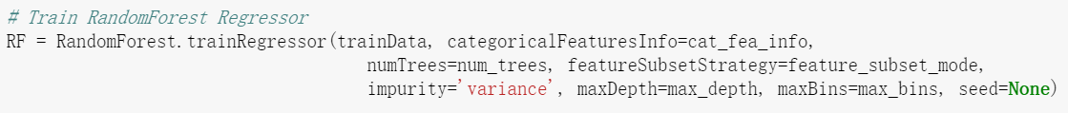
Figure2: Use of the “RandomForest.trainRegressor” function
We train three models respectively on three outcome variables: Count, Fare and Tip. And then use the root-mean-squared-error (RMSE) to test the performance of the three models on the test dataset. That the RMSE is smaller means the accuracy of a model is higher.
To tune the models, we use different combinations of hyperparameters to find the best model with minimum RMSE, as Figure 3.
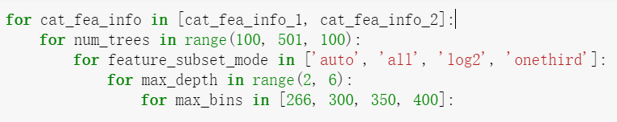
Figure3: Tune the Random Forest regression model with different value of hyperparameters.
Finally, we use the hyperparameters with the best accuracy to predict the outcome variables and save the models using PySpark.

Prediction results

The best model so far
As we discussed in the Section V, after trying different value of hyperparameters, we so far find the combination of hyperparameters which has the minimum RMSE:
- Number of trees: 300
- Number of features in each node to be selected to split the node:
log₂ (total number of features)
- Maximum depth of a tree: 4
- Maximum bins of each feature: 400
With this combination, the RMSEs on Count, Fare and Tip are 7.74, 7.73, 2.58

Use the models to predict ride demands
We have divided the New York City into 266 districts, each of which has a number representing it. Therefore, to predict the ride demands, we first need to find the number of that district. Hence, we implement a function that can return the number of a district by inputting the name of this district. For example, we input ‘Manhattan’ and ‘Midtown East’, then the function will return the number of this district – 162, as Figure 4 shows:
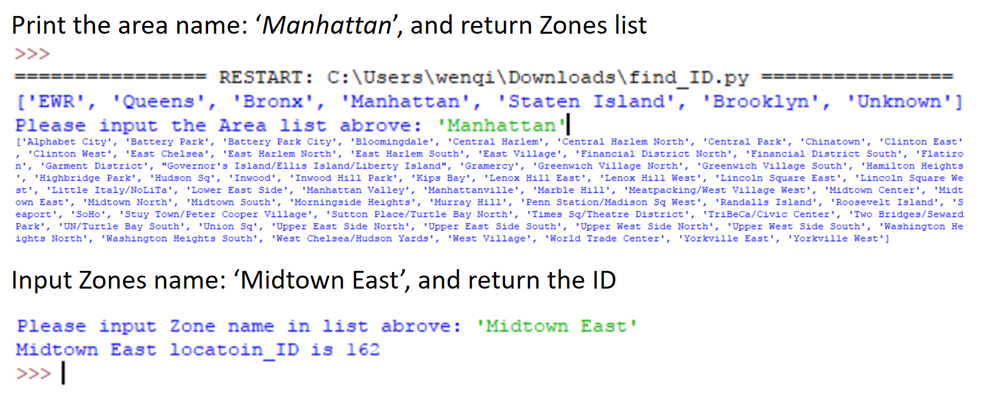
Figure4: The function that return the number of a district.
With the number, we can predict the Count, Fare and Tip at a moment in a day within a district in New York City, using the saved Random Forest regression model. For instance, we input ‘162, 10, 0’, we can get Count, Fare and Tip predictions in the ‘Manhattan - Midtown East’ district in 10 a.m. in a business day, as Figure 5 shows.
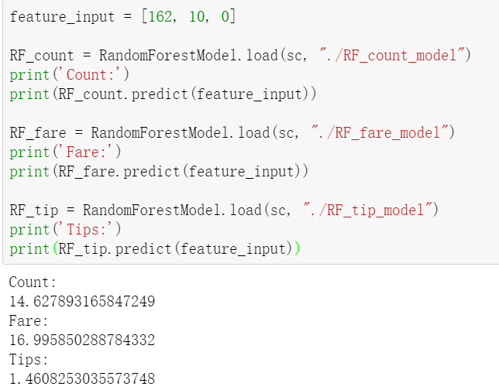
Figure5: The prediction of Count, Fare and Tip with input.
Please note that ‘162’ means the number of district ‘Manhattan - Midtown East’; ‘10’ means 10 a.m. in a day; ‘0’ means that day is a business day, while ‘1’ means that day is not a business day. And the result of the prediction is 14.6 ride demands on average in that hour in that district on that day, 17.0 dollars fare and 1.5 dollars tips per ride on average.

Conclusion
This project analyzes millions of NYC taxi rides data to find out relationship between taxi riding demands and relevant features on location, pickup time and business day. We predict hourly pickup ride amount, average fare amount, and tips amount based on our random forest regression algorithm. We implement the random forest machine learning model with Apache PySpark MLlib and tune the parameters to achieve good performance measured by RMSE. Since our model can help make traffic more efficient, it has a great business value.

References

- S. Zhang, H. Chen and G. Xiong, "marcogx/taxi-analysis", GitHub, 2017. [Online]. Available: https://github.com/marcogx/taxi-analysis. [Accessed: 18- Dec- 2017].
- T. W. Schneider, "Analyzing 1.1 Billion NYC Taxi and Uber Trips, with a Vengeance", 2017. [Online]. Available: http://toddwschneider.com/posts/analyzing-1-1-billion-NYC-taxi-and-uber-trips-with-a-vengeance/. [Accessed: 18- Dec- 2017].
- Y. Zheng, L. Capra, O. Wolfson and H. Yang, "Urban computing: concepts, methodologies, and applications", ACM Transactions on Intelligent Systems and Technology, vol. 5, no. 3, pp. 1-55, 2014.

